**School of Electronics and Communication Engineering**

**Second Year B. Tech. (ECE)**

**Hardware/Software Tools for Electronics Engineering Course Code: EC224**

**LED Machine Using Ultrasonic Sensor**

**Submitted by:**

**Mitali Jain (PA 07)**

**Piyush Pamnani (PA 34)**

**Ruchin Shroff (PA 35)**

**NAME OF THE GUIDE:**

Mrs. Ujjwala Rawandale

Dr. Vi6hwanath Karad

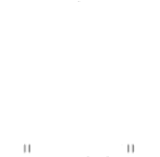

MIT-WPU

MIT WORLD PEACE

UNIVERSITY PUNE

**1. Introduction**

**Aim**:To create a project that can be applied in an architectural way.  To make an interactive consumer-driven light show. Using 4 (or more) rangefinders to drive the diode matrix along the (X; Y) axis and collect information in Excel.

**Basic Scope and Background**: The architectural way of this project reveals its potential when interacting with social environment, involving people by its conspicuous and creating the desire to take part in the interactive

**Objective**: A fully implemented project can become an excellent interactive and playful exhibition installation or media facade of a modern architectural building or pavilion.

Actually to participate in the creation of an optical design that reflects the silhouette and gestures of people passing by right on the LED Matrix wall, controlled

by proximity sensors.

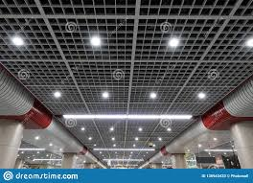

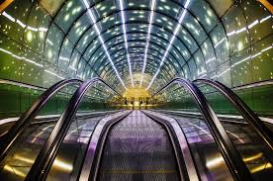

**2. Hardware Design**

Components and devices:

|  |  |  |  |
| --- | --- | --- | --- |
| Sr. No | Components | Range | Quantity |
| 1. | Arduino UNO | - | 1 |
| 2. | Ultrasonic Sensor | - | 1 |
| 3. | IC MAX7219 | - | 1 |
| 4. | Connecting Wires | - | - |
| 5. | LED Matrix | - | 1 |
| 6. | Variable Resistance | - | 1 |

Description of Components:

Arduino UNO:

Arduino is an open-source electronics platform based on easy-to-use hardware and software. Arduino boards can read inputs light on a sensor, a finger on a button, or a Twitter message and turn it into an output activating a motor, turning on an LED, publishing something online. The Arduino Uno is a microcontroller board based on the ATmega328. It has 14 digital input/output pins (of which 6 can be used as PWM outputs), 6 analog inputs, a 16 MHz ceramic resonator, a USB connection, a power jack, an ICSP header, and a reset button. It contains everything needed to support the microcontroller, simply connect it to a computer with a USB cable or power it with an AC-to-DC adapter or battery to get started. The Uno differs from all preceding boards in that it does not use the FTDI USB-to-serial driver chip. Instead, it features the Atmega16U2 (Atmega8U2 up to version R2) programmed as a USB-to-serial

converter.

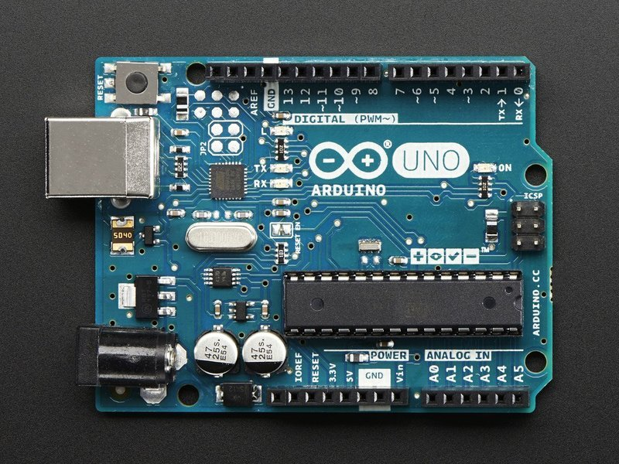

Ultrasonic Sensor:

An ultrasonic sensor is an electronic device that measures the distance of a target object by emitting ultrasonic sound waves, and converts the reflected sound into an electrical signal. Ultrasonic waves travel faster than the speed of audible sound (i.e. the sound that humans can hear). Ultrasonic sensors have two main components: the transmitter (which emits the sound using piezoelectric crystals) and the receiver (which encounters the sound after it has travelled to and from the target).

In order to calculate the distance between the sensor and the object, the sensor measures the time it takes between the emission of the sound by the transmitter to its contact with the receiver. The formula for this calculation is [**D = ½ T x C**](https://www.arrow.com/en/research-and-events/articles/ultrasonic-sensors-how-they-work-and-how-to-use-them-with-arduino) (where D is the distance, T is the time, and C is the speed of sound ~ 343 meters/second). For example, if a scientist set up an ultrasonic sensor aimed at a box and it took 0.025 seconds for the sound to bounce back, the distance between the ultrasonic sensor and the box would be:

Ultrasonic sensors are used primarily as [**proximity sensors**](https://www.fierceelectronics.com/sensors/what-a-proximity-sensor). They can be found in automobile self-parking technology and anti-collision safety systems. Ultrasonic sensors are also used in robotic obstacle detection systems, as well as manufacturing technology. [**In comparison to infrared (IR) sensors**](https://www.maxbotix.com/articles/ultrasonic-or-infrared-sensors.htm) in proximity sensing applications, ultrasonic sensors are not as susceptible to interference of smoke, gas, and other airborne particles (though the physical components are still affected by variables such as heat).

Ultrasonic sensors are also used as [**level sensors**](https://www.fierceelectronics.com/sensors/what-a-level-sensor) to detect, monitor, and regulate liquid levels in closed containers (such as vats in chemical factories). Most notably, ultrasonic technology has enabled the medical industry to produce images of internal organs, identify tumors, and ensure the health of babies in the womb.

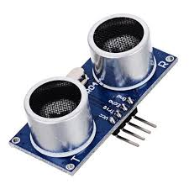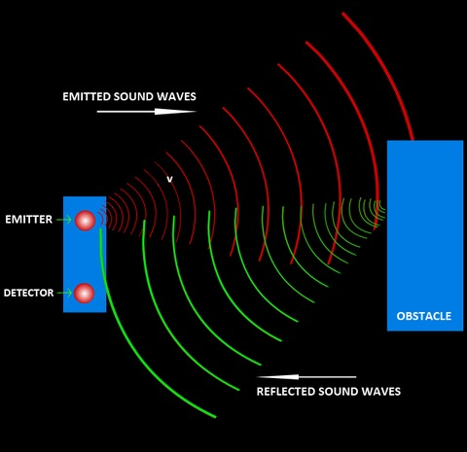

**IC MAX7219**

MAX7219 is a common-cathode display driver IC with serial inputs and output pins. It has an adjustable current capability which can be set using only one external resistor. In addition to that, it has a four-wire serial interface that can be easily connected to all microprocessors. It can drive 64 individual LEDs connected at its output pins using only 4 wires by using Arduino. Furthermore, it can drive dot matrix displays, 7-Segments displays

and bar graphs.

On top of that, MAX7219 has a built-in BCD decoder that makes it easy to use with seven segment numeric displays. Additionally, it has an 8×8 static RAM that we can use to store numbers. It is one of the most popular display driver IC

This IC has a total of 24 pins. The description of pins is:

Pin#01: DIN

It is the serial data input pin. This IC has an internal 16-bit shift register. On every low to high transition of clock signal, the data is loaded into this register.

Pin#02, 03, 05, 06, 07, 08, 10, 11: Digit Pins

These are common output pins for all the segments of digits 0 to 7. These pins sink current from the display common cathode.

Pin#04, 09: GND

This is the ground of the circuit.

Pin#12: LOAD ()

It is the chip select pin. For normal operation, it is connected to low logic level to clock data in or out. On the positive transition of this input, the data is latched into the control register. After the 16th rising clock edge, this input must go HIGH otherwise all the data will be lost.

Pin#13: CLK

This is the serial input pin for the clock signal. When CS is low, the CLK input signal is active. On the positive edge transition of a CLK signal, data is shifted into the internal shift register. This data is displayed on the DOUT pin at the falling edge of the clock signal.

Pin# 14, 15, 16, 17, 20, 21, 23: SEG_A to SEG G

These seven pins are all segments of the digits.

Pin#22: SEG DP

This is the segment pin for a decimal point.

Pin#18: ISET

This pin is used to set the output current by connecting a resistor at this pin whose other terminal is connected to the ground. This resistor is used to adjust the value of the current.

Pin#19: V+

It is the terminal for a positive power supply.

Pin#24: DOUT

It is the serial digital output pins..

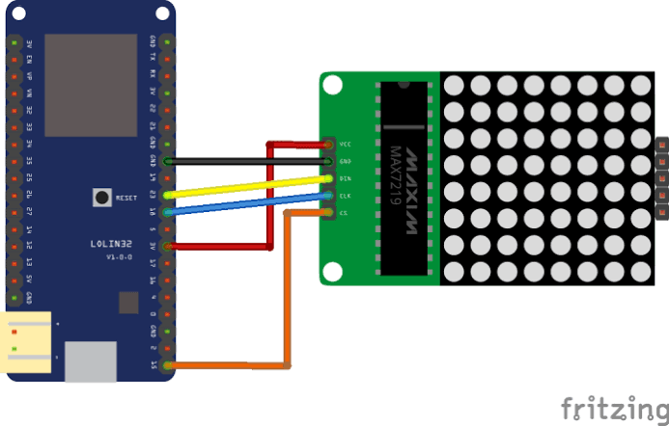

**LED Matrix:**

Led matrix is a dot matrix of large display, low resolution value and is useful for both industrial or commercial displays as well as for hobbyist human interface machines. In contains a 2-D diode matrix which have the cathode joined in rows and anode in columns. In this LED matrix each can be control individually by controlling the electricity through each pair of columns or rows diodes. These matrix are very popular matrix by means of displaying information it, allows the static and animated images and text.

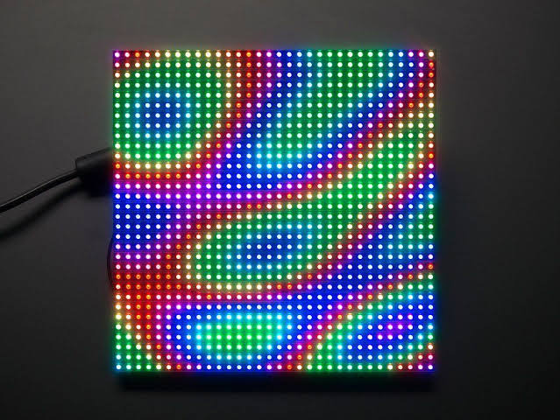

Circuit Diagram:

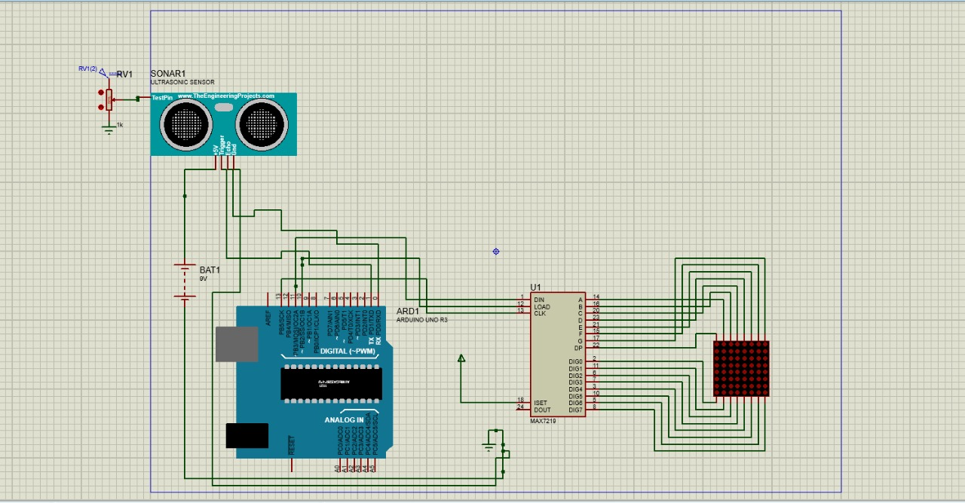

Working Principle:

 The components from the Arduino IOT Bundle are connected with one rangefinder sensor. As a result, the system starts working in one direction and sequentially lit up and extinguished the required row of diodes, depending on the distance to the object in front of the rangefinder.

The next stage of modernization is to make the light move along the (X; Y) axis.

Connect 4 proximity sensors as efficiently as possible. In the end, line them up next to each other and do this in a box cover so that they all give the same distance to the far border.

The prototype works according to the principle:

* It is determined in front of which of the sensors the object is located. This is how the column of diodes is sampled along the X axis.
* Having chosen the sensor with which to work, the distance to it is read and the illuminating diodes are searched along the Y axis.
* So when any object moves in front of the ultrasonic sensors that are placed in the box, the light on the RGB LED lit up , according to the movement of the object.

The Arduino Uno is a microcontroller board based on the ATmega328. It has 20 digital input/output pins (of which 6 can be used as PWM outputs and 6 can be used as analog inputs), a 16 MHz resonator, a USB connection, a power jack, an in-circuit system programming (ICSP) header, and a reset button.

Ultrasonic sensors emit short, high-frequency sound pulses at regular intervals. If they strike an object, then they are reflected back as echo signals to the **sensor**, which itself computes the distance to the target based on the time-span between emitting the signal and receiving the echo. ...

RGB LED controllers work on a much simpler principal. They alter the power on each of the three channels (red, green and blue) to create a specific **colour** mix. To generate a purple **colour**, for **example**, the red and blue channels would be wound up, and the green channel turned off completely.

Design:

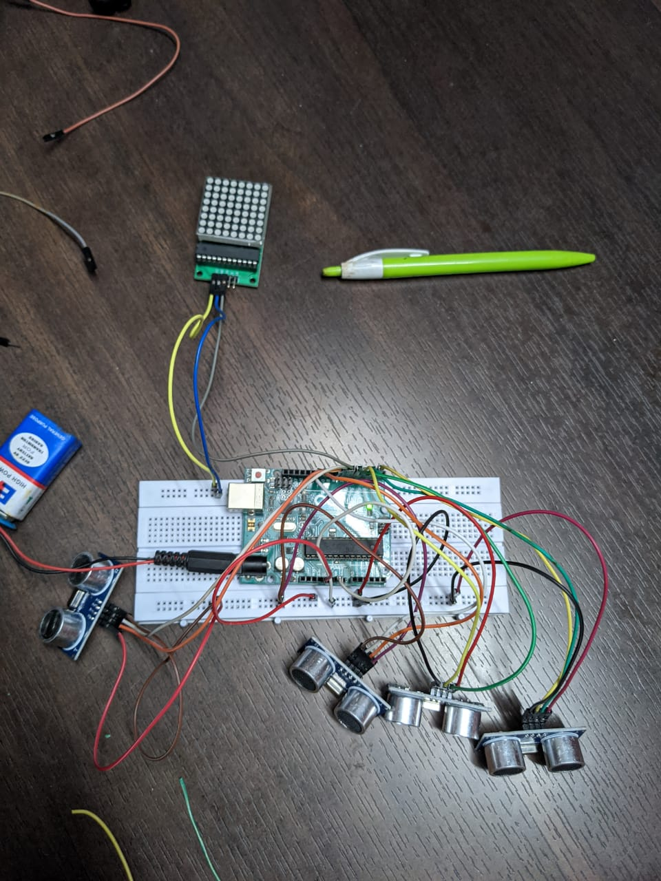

For All the sensors vcc and ground pins are connected to the breadboard the echo and trigger pin are connected to the digital part of the Arduino

LED Matrix DIN pin is connected to the digital six point of arduino and the VCC, ground are connected to the breadboard and battery. To prevent damage of the LED a resistor can be used. It is connected to the DIN of LED Matrix and Arduino vi digital pin.

Code:

#include <Adafruit_NeoPixel.h>

#include <Ultrasonic.h>

#define PIN 6

//#define NUMPIXELS 64

#define PIXEL_AMOUNT 64

#define BRIGHTNESS 150

int distance1 = 0;

int distance2 = 0;

int distance3 = 0;

int distance4 = 0;

int dist1 = 0;

int dist2 = 0;

int dist3 = 0;

int dist4 = 0;

int d1 = 0;

int d2 = 0;

int d3 = 0;

int d4 = 0;

int row_excel = 5;

Adafruit_NeoPixel strip = Adafruit_NeoPixel(64, 6, NEO_GRB + NEO_KHZ800);

Ultrasonic ultrasonic1(1, 0); // An ultrasonic sensor HC-04

Ultrasonic ultrasonic2(5, 4); // An ultrasonic sensor HC-04

Ultrasonic ultrasonic3(10, 11); // An ultrasonic sensor HC-04

Ultrasonic ultrasonic4(8, 7); // An ultrasonic sensor HC-04

int showType = 3;

void setColor(uint32_t c) {

for(uint16_t i = 0; i < strip.numPixels(); i++) {

strip.setPixelColor(i, c);

}

strip.show();

}

void setup() {

Serial.begin(9600);

strip.begin();

strip.show();

Serial.println("CLEARDATA");

Serial.println("Time, Sensor 01, Sensor 02, Sensor 03, Sensor 04");

}

void loop() {

{

row_excel++;

Serial.print("DATA,TIME,");

Serial.print(",");

if (ultrasonic1.read(CM)< 30)

//Serial.print("Sensor 01: ");

Serial.print(ultrasonic1.read(CM)); // Prints the distance on the default unit (centimeters)

//Serial.println("cm");

Serial.print(",");

if (ultrasonic2.read(CM)<30)

//Serial.print("Sensor 02: ");

Serial.print(ultrasonic2.read(CM)); // Prints the distance on the default unit (centimeters)

//Serial.println("cm");

Serial.print(",");

if (ultrasonic3.read(CM)<30)

//Serial.print("Sensor 03: ");

Serial.print(ultrasonic3.read(CM)); // Prints the distance in inches

//Serial.println("cm");

Serial.print(",");

if (ultrasonic4.read(CM)<30)

//Serial.print("Sensor 04: ");

Serial.print(ultrasonic4.read(CM)); // Prints the distance in inches

//Serial.println("cm");

Serial.print(",");

Serial.println(row_excel);

delay(100);

distance1 = ultrasonic1.read();

distance2 = ultrasonic2.read();

distance3 = ultrasonic3.read();

distance4 = ultrasonic4.read();

dist1 = ultrasonic1.read();

dist2 = ultrasonic2.read();

dist3 = ultrasonic3.read();

dist4 = ultrasonic4.read();

d1 = ultrasonic1.read();

d2 = ultrasonic2.read();

d3 = ultrasonic3.read();

d4 = ultrasonic4.read();

}

// 1 line

if ( distance1 >= 4 && distance1 <= 6 )

strip.setPixelColor(0, strip.Color(127, 127, 127));

else if ( distance1 >= 7 && distance1 <= 9 )

strip.setPixelColor(1, strip.Color(127, 127, 127));

else if ( distance1 >= 10 && distance1 <= 12 )

strip.setPixelColor(2, strip.Color(127, 127, 127));

else if ( distance1 >= 13 && distance1 <= 15 )

strip.setPixelColor(3, strip.Color(127, 127, 127));

else if ( distance1 >= 16 && distance1 <= 18 )

strip.setPixelColor(4, strip.Color(127, 127, 127));

else if ( distance1 >= 19 && distance1 <= 21 )

strip.setPixelColor(5, strip.Color(127, 127, 127));

else if ( distance1 >= 22 && distance1 <= 24 )

strip.setPixelColor(6, strip.Color(127, 127, 127));

else if ( distance1 >= 25 && distance1 <= 27 )

strip.setPixelColor(7, strip.Color(127, 127, 127));

// 2 line

else if ( d1 >= 4 && d1 <= 6 == d2 >= 4 && d2 <= 6 )

strip.setPixelColor(8, strip.Color(127, 127, 127));

else if ( d1 >= 7 && d1 <= 9 == d2 >= 7 && d2 <= 9 )

strip.setPixelColor(9, strip.Color(127, 127, 127));

else if (d1 >= 10 && d1 <= 12 == d2 >= 10 && d2 <= 12 )

strip.setPixelColor(10, strip.Color(127, 127, 127));

else if (d1 >= 13 && d1 <= 15 == d2 >= 13 && d2 <= 15 )

strip.setPixelColor(11, strip.Color(127, 127, 127));

else if (d1 >= 16 && d1 <= 18 == d2 >= 16 && d2 <= 18 )

strip.setPixelColor(12, strip.Color(127, 127, 127));

else if (d1 >= 19 && d1 <= 21 == d2 >= 19 && d2 <= 21 )

strip.setPixelColor(13, strip.Color(127, 127, 127));

else if (d1 >= 22 && d1 <= 24 == d2 >= 22 && d2 <= 24 )

strip.setPixelColor(14, strip.Color(127, 127, 127));

else if (d1 >= 24 && d1 <= 27 == d2 >= 25 && d2 <= 27 )

strip.setPixelColor(15, strip.Color(127, 127, 127));

Applications: LED architecture has many beautiful and large scale applications some of them are stated below

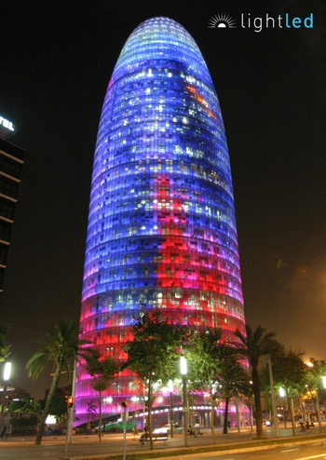  
  
Agbar Tower  
description Light-emitting diodes, or LEDs, are reinventing the look and feel of skylines, bridges, facades and other architectural surfaces around the globe. The light bulb is being unscrewed by energy-efficient LEDs that are both environmentally friendly and cost-effective. The $10.2 billion industry is growing to provide new design options for architects and planners. Left: This Barcelona office, designed by the French architect Jean Nouvel, brings color 142 meters into city skyline. A total of 4,500 L3 RGB lights were installed to illuminate the 32 floors of offices in the Agbar tower. The lighting system, which contains 4,500 L3 RGB lights, is controlled from a single computer.

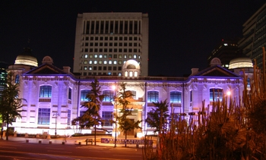

Bank of Korea  
description Korea’s central bank was created in 1950, to set price stability. The classically designed building has been given a modern face lift with this purple LED lighting.Photo: Courtesy of and copyrighted by Tryka L.E.D. and C C&C Electronics

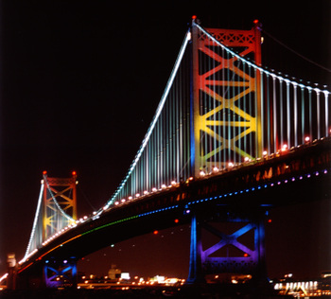

Ben Franklin Bridge  
description This bridge in Philadelphia was given a dramatic overhaul when lights were added to the anchorages and towers. Old and rusting bridges can be given new life with a rainbow of colors. With a declining cost in maintenance, LED lights can now be used to decorate bridges and other structures that are subject to rusting.

Conclusion:

A fully implemented project can become an excellent interactive and playful exhibition installation or media facade of a modern architectural building or pavilion.

The architectural way of this project reveals its potential when interacting with social environment, involving people by its conspicuous and creating the desire to take part in the interactive. Actually to participate in the creation of an optical design that reflects the silhouette and gestures of people passing by right on the LED Matrix wall, controlled by proximity sensors.

**Architectural lighting design** is a field of work or study that is concerned with the design of lighting systems within the built environment, both interior and exterior.

Lighting design is based in both and the visual arts. The basic aim of lighting within the built environment is to enable occupants to see clearly and without discomfort.

References:

1. <https://www.kth.se/en/studies/master/architectural-lighting-design/description-1.7255>
2. <https://en.wikipedia.org/wiki/Architectural_lighting_design>
3. [www.google.com](http://www.google.com)
4. https://www.electronicwings.com
5. [www.cdsys.co.uk](http://www.cdsys.co.uk)
6. [www.circuitsgallery.com](http://www.circuitsgallery.com)
7. [www.circuitdigest.com](http://www.circuitdigest.com)
8. <https://www.researchgate.net/>